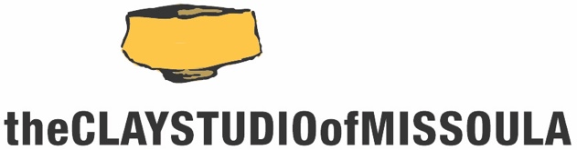

The Clay Studio of Missoula/University of Montana
Summer Residency Opportunity

The Clay Studio of Missoula invites current students or recent graduates* of the University of Montana with experience and an avid interest in ceramics to apply for our Summer UM Residency.

For roughly 3 months during the summer (late May-late August), the UM Resident will work in the community studio space, which consists of shared general studio area, and be given shelf space to store work and supplies. For the general public, this usually costs $150/mo plus an annual membership, but all these fees are waived for the UM Resident.

- All residents have 24/7 access to the facility
- UM residents will have the same obligations as other residents (studio and gallery duties up to 5 hr/wk, plus create six cups and plates for our Summertime High Tea fundraiser in late August 2023)
- All residents are responsible for material expenses and firing fees
- The UM Resident will be asked to assist with Summer workshops**

There is no application fee for the UM Student Residency. Applicants must complete the application form and include other documentation listed on the application form. Applications are due no later than Thursday April 6, 2023
All applicants will be notified of results no later than the end of April.

To learn more about The Clay Studio of Missoula, please visit www.theclaystudioofmissoula.org. This application can be downloaded from the site in the Residency Application section.

*recent graduates includes any student successfully completing their studies in the 2022/23 academic year
** As of February 2-23 we do not have any scheduled workshops for summer 2023, but will update applicants if and when that changes
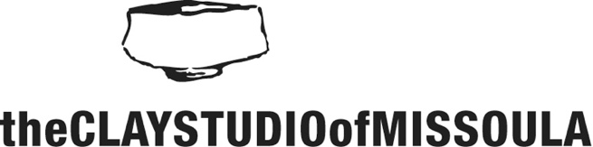 | University of Montana  Student Residency Application  due: Thursday, April 6, 2023
Name:_________________________________ preferred pronouns:_____________

Mailing Address:____________________________________________________
City:__________________________ State:_________ Zip Code:_____________

Best Contact Phone #:______________________

Email:________________________________ Website:_______________________________ (if available)

Name of one UM ceramics faculty member who supports your application and can speak to your qualifications as a potential resident:

____________________________________________________________________________

Please include the following materials to complete your application:

- Letter of intent indicating your interest in a UM Student Residency at The Clay Studio of Missoula
- 10 high-quality digital images of your work (at 4x6, 300 dpi) sent via Dropbox or Google Drive to info@theclaystudioofmissoula.org by the application deadline
- Image inventory sheet labeled with the title, corresponding number, date, medium and dimensions
- Artist Resume & Artist Statement

___Mark here to confirm images were sent via Dropbox or Google Drive to info@theclaystudioofmissoula.org

APPLICATIONS MUST BE RECEIVED NO LATER THAN THURSDAY APRIL 6, 2023

APPLICATION MATERIALS MUST BE SUBMITTED BY EMAIL: info@theclaystudioofmissoula.org

We will confirm receipt of your application within 2 business days (M-F).

If you have any questions, please feel free to contact us
Email: info@theclaystudioofmissoula.org/ Phone: 406-543-0509

